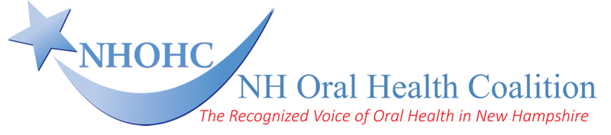

THE ALPHONSE J. “SKIP” HOMICZ Jr. LEGACY AWARD

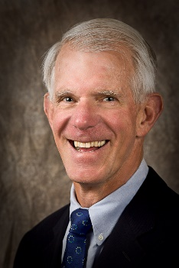
The New Hampshire Oral Health Coalition (NHOHC) established the Alphonse J. “Skip” Homicz Jr. Legacy Award in 2023. Dr. Homicz, or Skip as he was known by colleagues and friends, was a widely respected and recognized general dentist and oral health advocate for over 50 years.

Dr. Homicz’s vast career began when he served as a Lieutenant in the United States Navy Dental Corps. After completing his service, he provided comprehensive dental care in private practice in Antrim, NH for over 30 years. After several mission trips to Haiti with the Haitian Health Foundation to deliver emergency oral health services, and after leaving private practice, Dr. Homicz began to focus his work at home in public health dentistry. He became the Dental Director of Families First Health and Support Center, a Federally Qualified Health Center (FQHC) in Portsmouth, NH. Under his leadership, Families First opened a dental center for the community. Later, Dr. Homicz led the organization’s expansion of dental services for individuals experiencing homelessness through a mobile dental program.

A leader in oral health in the state and nationally, Dr. Homicz was a founding member of the NH Oral Health Coalition because he was concerned about the impact of oral health issues facing individuals across the state. For several years Dr. Homicz served as Chair of the Coalition’s Steering Committee. He was deeply committed to the organization’s mission and vision, to advance and promote oral health for the people of New Hampshire, and that through improved oral health, the people of New Hampshire will have enhanced quality of life and opportunity.

In addition to serving as Chair for the NH Oral Health Coalition, Dr. Homicz served as President of the NH Dental Society. He also served on the American Dental Association’s Council on Access, Prevention and Interprofessional Relations which focuses on strategies to improve Oral Health Literacy, Oral Disease Prevention and Intervention, Access to Oral Healthcare, and Community Oral Health Advocacy.

Dr. Homicz was an inspirational colleague, mentor, and agent of change. He was always interested in learning; he was a great listener; he was willing to consider how diverse ways of thinking could advance work. He was willing to try new and innovative approaches. He was compassionate and engaging.

This Award honors Dr. Homicz’s legacy and passionate commitment to improving the oral health of populations most in need of care. It recognizes an individual or a New Hampshire nonprofit organization that best demonstrates and exemplifies his commitment to increasing access to oral health care in their community and/or the state.

The Award is presented to qualified candidates by the NH Oral Health Coalition at its annual meeting. This year’s meeting is scheduled for Friday, December 6, 2024.

Nomination Process

Eligible Nominees

- An Individual is a New Hampshire oral health professional, educator, and/or advocate for public oral health services.
- A Non-profit organization is an entity working in New Hampshire whose mission includes improving the oral health of the people of New Hampshire.

Both the individual and the organization must be nominated by someone other than themselves, either by another individual, or an organization.

In recognition of their work the recipient receives a stipend in the amount of $2,500. Awards to individuals or organizations are subject to taxes as applicable by law.

Award Criteria

Examples of criteria to be considered for selection are listed below:

Individual

- Demonstrates exceptional commitment to, and impact on, the oral health of the people of New Hampshire.
- Is recognized as a leader in the oral health field.
- Serves as a role model to others.
- Is a passionate advocate for improved access to oral health services.
- Provides, advocates, and/or supports compassionate, non-judgmental care to all patients.
- Demonstrates a commitment to learning and working in partnerships to advance oral health.
- Seen as an ambassador in the public oral health field by recruiting, teaching, and training others to serve.

Organization

- Has a track record of providing excellent oral health services, particularly to underserved populations.
- Is exceptionally committed to improving access to oral health services for the people of New Hampshire.
- Is recognized as a leading advocate for improving oral health services.
- Is regarded as a state or community leader in the oral health field.
- Implements and/or advocates for oral health integrated with overall health services.

Application Procedure

Homicz Legacy Award Nomination Application

The completed application form should not exceed two pages and should describe:

- The nominee’s exemplary commitment to improving the oral health of underserved populations in New Hampshire.
- Specifics about the nominee’s record of achievement in meeting some or all the criteria listed above.
- A description of how the nominee’s work has impacted access to oral health in the state and/or their community.

The application should also include two current letters of support that address the contribution the nominee has made and why the nominee deserves this recognition.

Submissions:

- Electronic submission must be made by Friday, July 19, 2024, to Application@nhoralhealth.org.
- Written submissions must be post-marked by Friday, July 19, 2024, and be mailed to: Gail Brown, Executive Director, The NH Oral Health Coalition,
4 Park Street, Suite 212, Concord, NH 03301.

Selection

Selection of the award recipient will be made by a review panel of the NH Oral Health Coalition. The selected nominee will be notified of the result at least 60 days prior to the Coalition’s annual meeting.

Please forward any questions to Gail T. Brown, Executive Director at gbrown@nhoralhealth.org.

